Name:__________________________ Date:_______________

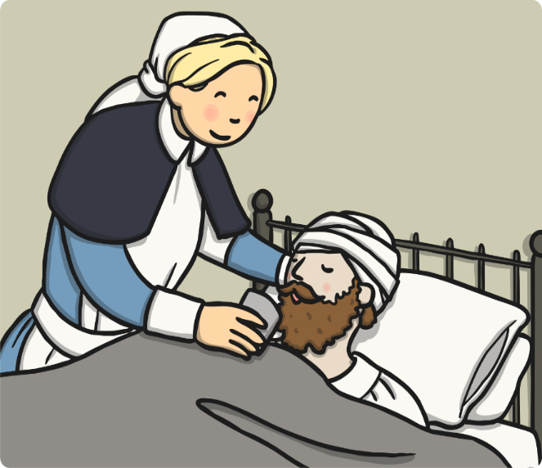
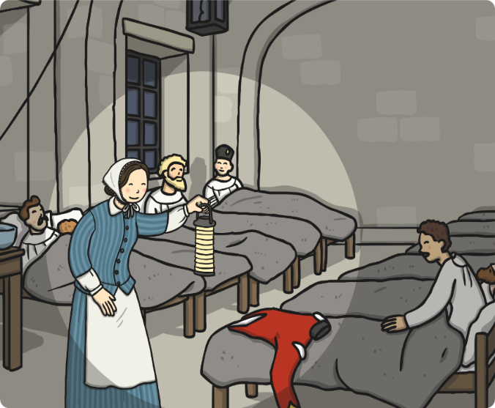
How did Florence Nightingale Improve Nursing?

___________________________________________________________________________________________________________________________________________________________________________________________________________________________________________________________________________________________________________________________________________________________________________________________________________________________________________________________________

